Motivators: Agreements and Conflicts
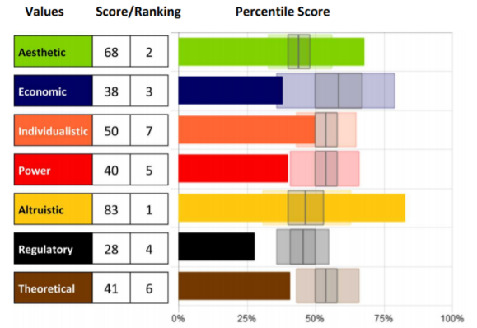
Understanding what motivates us,
what inspires us, and is deemed
important by us is a vital first step
in self-awareness and improving
human performance and effectiveness.
Knowing our specific level of motivation can
be crucial to helping us understand what
drives our beliefs and actions so we can
bring them into alignment.

Common Agreements
When you have agreement in Motivators, the impact of those motivators multiplies and becomes stronger.

• High Aesthetic | High Individualistic = both represent creativity, out-of-the-box ideas, and uniqueness
AES
IND

• High Individualistic | Low regulatory = both represent independence and personal freedom
IND
REG

• High Economic | High Power = both represent competitive, controlling, self-interested ideas
ECO
POW

• Low Individualistic | High Altruistic = both represent willing and accommodating attitude
IND
ALT

• Low Economic | High Altruistic = both represent the interest of others over self
ECO

ALT

Common Conflicts
Conflicts take place when there is less agreement and more conflict between two or more values. These scenarios represent common disagreements between values. Conflicts can be internal or external.

INTERNAL CONFLICT COMBINATIONS
• High Economic | Low Power = wants to win, but will not put self in the position to win or not play hard enough to win
ECO
POW

• High Individualistic | High Regulatory = desires unique and exciting things, but may be risk averse
REG
IND

• Low Economic | High Power = desires to control one’s own destiny but lacks the competitive spirit to make it happen
ECO
POW

EXTERNAL CONFLICT COMBINATIONS
• High Individualistic | Low Altruistic = may appear self-centered
ALT
IND
ALT
ALT
• High Power| High Regulatory | High Theoretical = this creates a know-it-all
POW
REG
POW
THE

• High Economic | Low Altruistic = will be seen as selfish and suspicious of others
ECO
ALT

- What Agreements do you see in your graph?
- What Conflicts do you see in your graph?
- What is the impact of these Agreements and Conflicts?

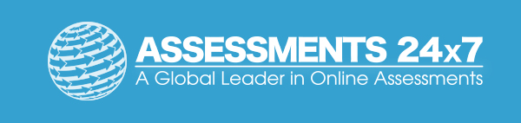Assessments 24x7 LLC 5927 Balfour Court, Ste. 103 Carlsbad, California 92008 USA (206) 400-6647

